|  |
| --- |
|  |
| IDS 572 Assignment 4 |
|  |

|  |
| --- |
| Aditi Vishwasrao – 674849041  Mounica Sirineni - 652518967  Nishanth Reddy Konkala - 658824939 |

**1. Explore the data to obtain an understanding of users, movies and how users have rated movies.**

**a) What is the overall distribution of ratings?**



***Figure 1.1 Overall Distribution of ratings***

Movies have been rated from values 1 to 5 by users where 1 stands for a low rating and 5 stands for a high rating.

From the above figure 1.1, we can see that the distribution of ratings is slightly skewed to the left. This means that most movies have been rated high by users. Nearly 35% of the movies have a rating 4 and more than 25% have a rating of 3.

The average movie rating is 3.524.

**b) On average, how do users rate movies; what ratings do movies have on average?** 

***Figure 1.2 Average movie ratings and user ratings***

We can see from the above plot that a user has given an average rating of 3.6 to movies. However, a movie has received an average rating of only about 3.1. Most movies have lower average ratings. However, there is no particular trend visible in the average ratings given by users.

**c) How many movies do users rate, and how many ratings do movies get?**



***Figure 1.3 Number of movies rated by users***

On an average users rate about 95 movies. The median of this distribution is 55. This means that most users rate a lower number of movies compared to the average. The range of the number of movies that users rate, however, is very large. The minimum number of movies rated by a user is 10 and the maximum is 727.



***Figure 1.4 Number of ratings for movies***

The distribution of the number of ratings that movies get is highly right skewed. This means that most movies get a lower count of ratings. A movie get around 50 ratings on an average. However, the median of the distribution is much less at approximately 25.

The range of the number of ratings a movie gets ranges from 1 to 495.

**d) How are rating levels distributed, do many people have high/low ratings?**



***Figure 1.5 Distribution of rating level and trend in ratings***

From the above graph we can infer the following:

* Less number of users have chosen to give lower rating to a movie.
* Most users have chosen to give an average or high rating to a movie.
* Most movies have received a rating of 3. A slightly lower number of movies have a rating of 2 and 4.
* The number of movies being rated low is much higher than the number of movies being rated high.
* Also, as is evident from the above figure and also from figure 1.1, the number of low ratings is lesser than high ratings.

**2. Consider collaborative filtering based rating prediction. We will evaluate performance of different approaches for predicting ratings.**

**What measures will you use for assessing performance (why)?**

The performance of the model can be evaluated based on the following 3 parameters:

1. RMSE- Root Mean Square error
2. MAE-Mean Absolut Error
3. NMAE-Normalized Mean Absolut error.

We chose the above predictive accuracy metrics instead of classification accuracy metrics because we want to recommend movies to the users with least error. At different levels of ratings, we examine the error to assess the performance of the model.

**And what relationships will you examine -- for example, error (or accuracy) at different levels of ratings; are errors distributed equally across movies, users? etc.**

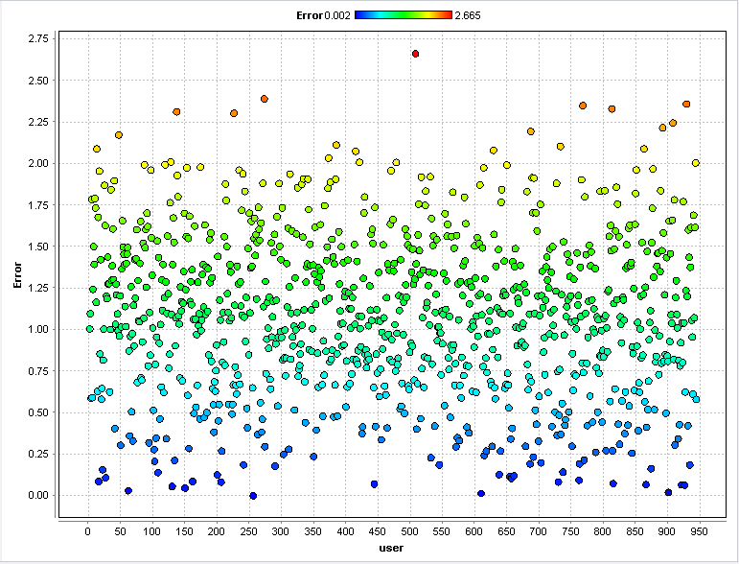

***Figure 2.1 Error distribution among users***

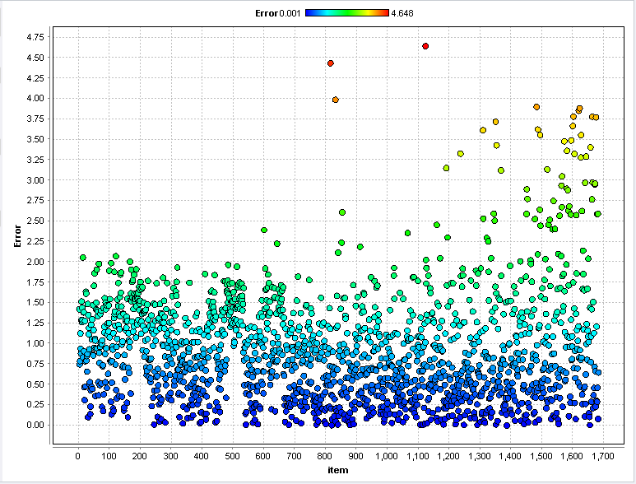

***Figure 2.2 Error distribution among movies***

From the above figures, we observe that there is no pattern distribution of errors among users and movies.

**(a) Use the Global Average method and User-Item Baseline methods. Do you find any performance differences? Do parameter changes for the user-item baseline operator make any difference?**

**Global Average method**

Global average method uses the average rating value over all ratings for prediction. We used minimum rating as “1” and range as “5”. The errors for this method are:

***Table 2.1 Global Average method performance***

|  |  |  |  |
| --- | --- | --- | --- |
| Data set | RMSE | MAE | NMAE |
| Training data | 1.126 | 0.945 | 0.236 |
| Testing data | 1.122 | 0.945 | 0.236 |

Click here for global average method performance vector

**User-Item Baseline method**

User-Item Baseline method uses the average rating values, plus a regularized user and item bias for prediction.

**Parameters:**

Minimum rating is 1 and Range is 5. Number of iterations did not have any impact on the performance vector. We got same values for different values of number of iterations and a fixed regularization parameter. So we used number of iterations as “10” and changed regularization parameters to know the effect and the results are tabulated below.

***Table 2.2 User-Item Baseline method performance***

|  |  |  |  |  |
| --- | --- | --- | --- | --- |
| **Regularization parameter** | **Data set** | **RMSE** | **MAE** | **NMAE** |
| Reg u = 15.0  Reg I = 10.0 | Training data | 0.920 | 0.729 | 0.182 |
| Testing data | 0.963 | 0.765 | 0.191 |
| Reg u = 20.0  Reg I = 15.0 | Training data | 0.925 | 0.734 | 0.183 |
| Testing data | 0.967 | 0.769 | 0.192 |
| Reg u = 25.0  Reg I = 20.0 | Training data | 0.930 | 0.738 | 0.185 |
| Testing data | 0.971 | 0.773 | 0.193 |
| Reg u = 30.0  Reg I = 25.0 | Training data | 0.934 | 0.743 | 0.186 |
| Testing data | 0.974 | 0.777 | 0.194 |

From the table, we observe that errors increase with increase in regularization parameters for user (reg u) and item (reg i). We get best method at reg u = 15.0 and reg I = 10.0. Click here for User-Item Baseline method performance vector.

**Conclusion:** When we compare errors in global average method and user-item baseline methods, we observe that errors are less in user-item baseline method. The regularization parameter in user-item baseline method helps to reduce overfit. Also, it supports several iterations of alternating optimization, instead of just one. Therefore, best method is **User-Item Baseline method**.

**(b) Use the Matrix factorization operator. Explore performance with varying number of factors. Does learning rate make a difference to performance?**

Matrix factorization operator factorizes the observed rating values using a factor matrix for users and one for items.

**Parameters:**

Min rating = 1

Range = 4

***Table 2.3 Matrix factorization performance***

|  |  |  |  |  |
| --- | --- | --- | --- | --- |
| **Parameters** | **Data set** | **RMSE** | **MAE** | **NMAE** |
| Num Factors = 10  Learn rate = 0.01 | Training data | 0.744 | 0.584 | 0.146 |
| Testing data | 0.976 | 0.764 | 0.191 |
| Num Factors = 25  Learn rate = 0.01 | Training data | 0.596 | 0.465 | 0.116 |
| Testing data | 1.021 | 0.799 | 0.200 |
| Num Factors = 50  Learn rate = 0.01 | Training data | 0.436 | 0.338 | 0.084 |
| Testing data | 1.030 | 0.811 | 0.203 |
| Num Factors = 10  Learn rate = 0.1 | Training data | 1.106 | 0.925 | 0.231 |
| Testing data | 1.120 | 0.941 | 0.235 |
| Num Factors = 10  Learn rate = 0.001 | Training data | 0.795 | 0.613 | 0.153 |
| Testing data | 1.099 | 0.849 | 0.212 |

**Conclusion:** From the table, we observe that as the number of factors increase, errors in training data decrease but increase in testing data. In such a case, when number of factors is “10”, the difference between training and testing data errors is minimum. As we increase learning rate, we observe that training and testing data errors decrease and then increase. As a trade-off, the best parameters are number of factors = 10 and learning rate = 0.01. Click here for matrix factorization performance vector.

**(c) Use the User-knn and Item-knn operators. Explore performance with varying the number of nearest neighbors k? Also do you notice any differences between using the cosine similarity measure and the Pearson measure? Are the neighborhood sizes, k, that give good performance, comparable across the two operators (why?)?**

**User-knn**

***Table 2.4 User-KNN performance***

|  |  |  |  |  |
| --- | --- | --- | --- | --- |
|  |  | **K** | **Training** | **Testing** |
|  |  | 60 | 0.922 | 0.957 |
| RMSE | Cosine | 70 | 0.923 | 0.957 |
|  |  | 80 | 0.923 | 0.957 |
|  |  | 90 | 0.923 | 0.957 |
|  |  |  |  |  |
| RMSE | Pearson | 60 | 0.795 | 0.949 |
|  |  | 70 | 0.800 | 0.949 |
|  |  | 80 | 0.804 | 0.949 |
|  |  | 90 | 0.807 | 0.949 |
|  |  |  |  |  |
| MAE | Cosine | 60 | 0.724 | 0.754 |
|  |  | 70 | 0.725 | 0.754 |
|  |  | 80 | 0.725 | 0.754 |
|  |  | 90 | 0.726 | 0.755 |
|  |  |  |  |  |
| MAE | Pearson | 60 | 0.619 | 0.746 |
|  |  | 70 | 0.623 | 0.746 |
|  |  | 80 | 0.627 | 0.746 |
|  |  | 90 | 0.629 | 0.746 |
|  |  |  |  |  |
| NMAE | Cosine | 60 | 0.181 | 0.189 |
|  |  | 70 | 0.181 | 0.189 |
|  |  | 80 | 0.181 | 0.189 |
|  |  | 90 | 0.181 | 0.189 |
|  |  |  |  |  |
| NMAE | Pearson | 60 | 0.155 | 0.186 |
|  |  | 70 | 0.156 | 0.186 |
|  |  | 80 | 0.157 | 0.186 |
|  |  | 90 | 0.157 | 0.187 |

**Conclusion:** In most of the cases, there was no change in error when the ‘K’ value changed. In the cases where there is change in the error, it is observed that the error value is least for small value of K. The error value is less when Pearson coefficient is used. The neighborhood size, which is giving the best results, doesn’t give the same error in both the operators. Therefore, the best model in our case is with **Pearson coefficient, K=60.** Click here to view the performance vector User KNN.

**Item-knn**

***Table 2.5 Item-KNN performance***

|  |  |  |  |  |
| --- | --- | --- | --- | --- |
|  |  | **K** | **Training** | **Testing** |
|  |  | 60 | 0.899 | 0.944 |
| RMSE | Cosine | 70 | 0.901 | 0.945 |
|  |  | 80 | 0.902 | 0.945 |
|  |  | 90 | 0.903 | 0.946 |
|  |  |  |  |  |
| RMSE | Pearson | 60 | 0.733 | 0.938 |
|  |  | 70 | 0.740 | 0.938 |
|  |  | 80 | 0.745 | 0.938 |
|  |  | 90 | 0.750 | 0.938 |
|  |  |  |  |  |
| MAE | Cosine | 60 | 0.706 | 0.742 |
|  |  | 70 | 0.707 | 0.743 |
|  |  | 80 | 0.709 | 0.743 |
|  |  | 90 | 0.710 | 0.744 |
|  |  |  |  |  |
| MAE | Pearson | 60 | 0.572 | 0.736 |
|  |  | 70 | 0.578 | 0.736 |
|  |  | 80 | 0.583 | 0.736 |
|  |  | 90 | 0.587 | 0.737 |
|  |  |  |  |  |
| NMAE | Cosine | 60 | 0.177 | 0.186 |
|  |  | 70 | 0.177 | 0.186 |
|  |  | 80 | 0.177 | 0.186 |
|  |  | 90 | 0.177 | 0.186 |
|  |  |  |  |  |
| NMAE | Pearson | 60 | 0.143 | 0.184 |
|  |  | 70 | 0.145 | 0.184 |
|  |  | 80 | 0.146 | 0.184 |
|  |  | 90 | 0.147 | 0.184 |

**Conclusion:** In most of the cases, there was no change in error when the ‘K’ value changed. In the cases where there is change in the error, it is observed that the error value is least for small value of K. The error value is less when Pearson coefficient is used. The neighborhood size, which is giving the best results, doesn’t give the same error in both the operators. For the same values of ‘K’, the errors in USER KNN operator are slightly higher than the item KNN. Therefore, the best model in our case is **Item –KNN, Pearson coefficient, K=60.** Click here to view the performance vector for Item KNN

**Comparing performance across the different operators, which would you prefer to use (why)?**

When we compare errors across all operators used in question2, Item KNN has least. So, the best method is Item KNN.

**3. Consider the decision support objective of recommending movies to users. Movies predicted to receive high ratings will be recommended for a user. We then need to determine a cutoff rating for 'high' (for example, any rating >=4 is 'high'). To access performance for this, we can consider a confusion matrix and related measures like precision, sensitivity etc (or, how many predicted highs correspond to actual high, etc.). Using the predicted ratings for the test data, determine such decision support performance using the operators in Question 2. Comparing performance across the different operators, which would you prefer to use (why)? What value of 'cutoff' will you use?**

***Table 3.1 Comparison of different cutoff values***

|  |  |  |  |
| --- | --- | --- | --- |
| **Cutoff** | **Overall Accuracy** | **Class Recall (true Y)** | **Class Recall (true N)** |
| 3.5 | 70.67% | 75.63% | 63.82% |
| 3.7 | 68.77% | 63.58% | 75.94% |
| 4.0 | 61.87% | 41.85% | 89.50% |

From the above table, we observe that we get maximum accuracy and recall for cut-off = 3.5.

***Table 3.2 Comparison of different methods with cut-off = 3.5***

|  |  |  |  |
| --- | --- | --- | --- |
| **Method** | **Overall Accuracy** | **Class Recall (true Y)** | **Class Recall (true N)** |
| Global Average | 58% | 100% | 0% |
| User-Item Baseline | 69.53% | 74.86% | 62.18% |
| Matrix Factorization | 68.44% | 73.72% | 61.15% |
| User KNN | 70.18% | 75.88% | 62.31% |
| Item KNN | 70.67% | 75.63% | 63.82% |

From the above table, we observe that among all methods, we get maximum accuracy and recall for Item KNN. Click here for the performance vector of Item KNN.

Therefore, when we consider errors in question 2 and accuracy in question 3, we observe that **Item KNN with Pearson coefficient and K = 60** is the best method.

**Are errors distributed equally across movies and across users?**

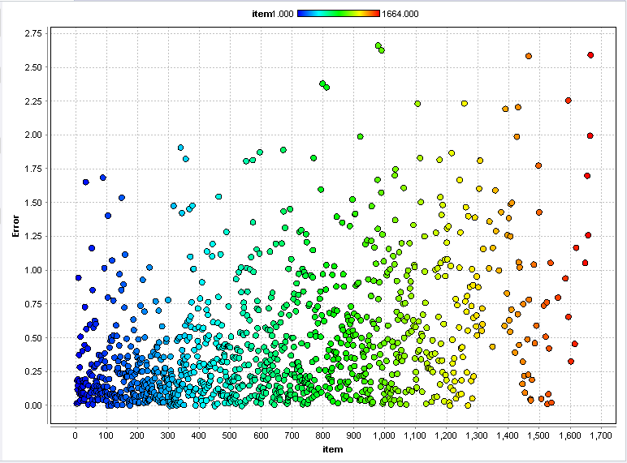

***Figure 3.1 Error distribution among movies***

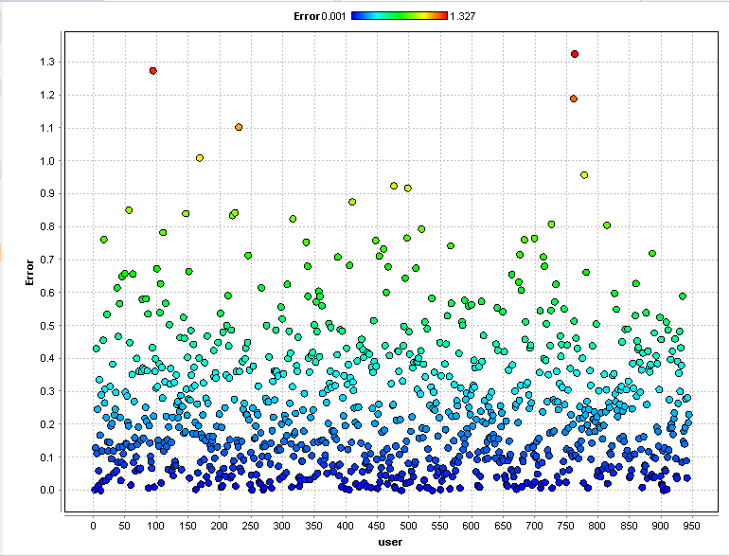

***Figure 3.2 Error distribution among users***

From figure 3.1, we observe that maximum movies have error in the range of 0.0 and 0.5. From figure 3.2, maximum users have error in the range of 0.0 and 0.3.

**4. Appendix**

**4.1 Global Average method** **[Back to the top]**

**4.1.1 Training data performance vector**

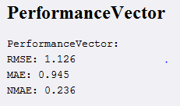

**4.1.2 Testing data performance vector**

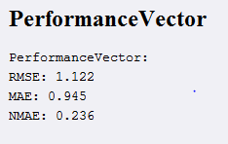

**4.2 User-Item Baseline method** **[Back to the top]**

**4.2.1 Training data performance vector**

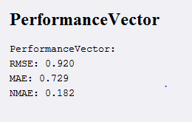

**4.2.2 Testing data performance vector**

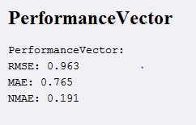

**4.3 Matrix Factorization** **[Back to the top]**

**4.3.1 Training data performance vector**

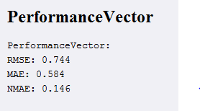

**4.3.2 Testing data performance vector**

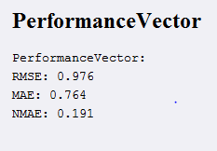

**4.4 User K-NN** **[Back to the top]**

**4.4.1 Parameters**

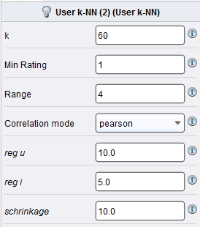

**4.4.2 Training data performance vector**

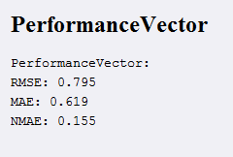

**4.4.3 Testing data performance vector**

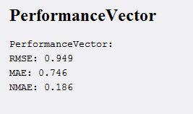

**4.5 Item K-NN** **[Back to the top]**

**4.5.1 Parameters**

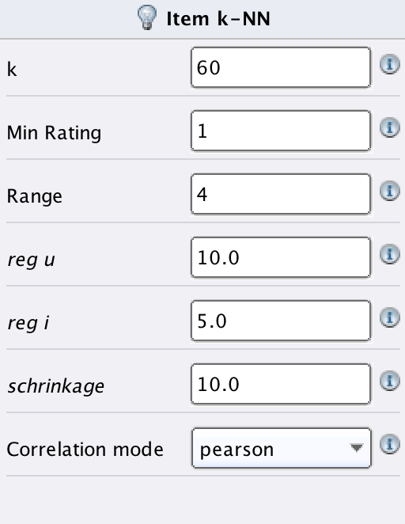

**4.5.2 Training data performance vector**

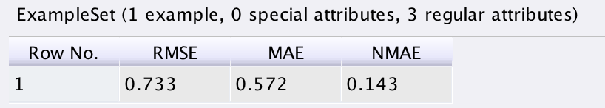

**4.5.3 Testing data performance vector**

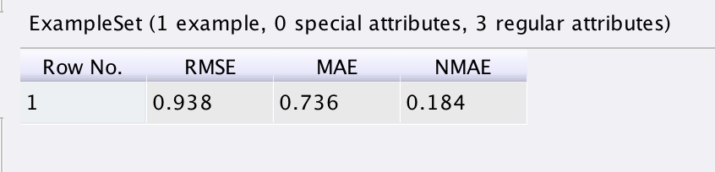

**4.6 Item KNN performance vector** **[Back to the top]**

